**Functional Document**

|  |  |
| --- | --- |
| **Application** | NGERP – Centra |
| **Service Bundle** | Inventory Management |
| **Service Request** | Internal Transfer Invoice |

**Description:**

In **Compiere (NGERP – Centra) ,** An Internal Transfer Invoice is used to record and manage transactions between different organizations or departments within the same company. It ensures that goods or services transferred internally are invoiced accurately, allowing for seamless financial tracking.

**Workflow Process:**

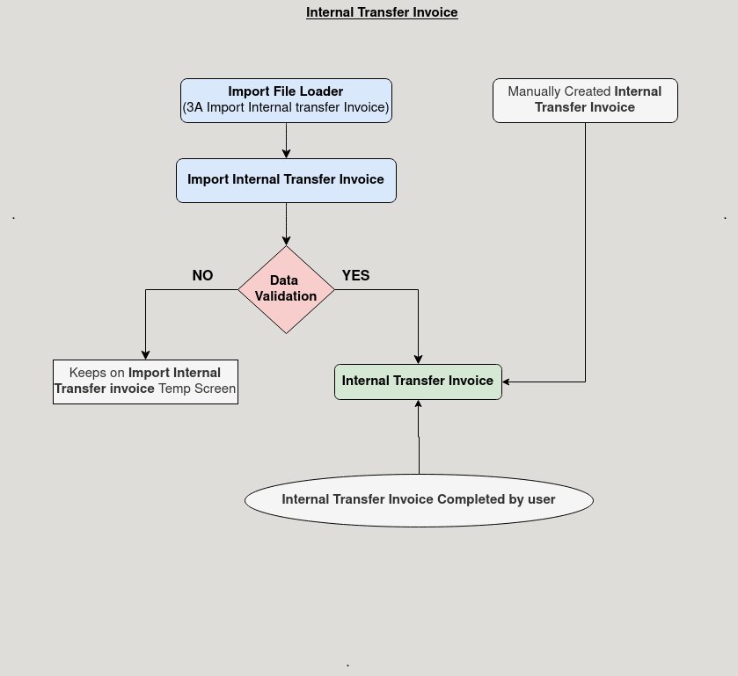

**Business Rules:**

* It is visible in both **HQ** and **ROW.**
* **Creation** is possible only in **ROW.**
* In **HQ ,** will be showing all region Data.
* Transaction Organization must be selected before creating the invoice, ensuring correct allocation between internal entities.
* Paid Checkbox will be ticked when payment is fully allocated. it remains unticked for partial payments to maintain accuracy.